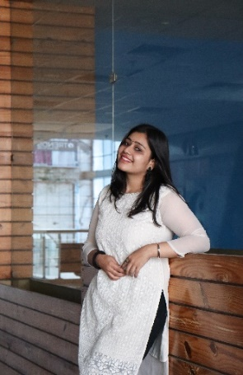 **Palak Sharma**

**Email:** Palak2001sharma@gmail.com

**Phone**: 9817492957

**LinkedIn**:  https://www.linkedin.com/in/palaksharmaconnect/

**GitHub**:  https://github.com/lissome-liv

|  |  |  |
| --- | --- | --- |
| **EDUCATION** |  | **ACHIEVEMENTS** |
| **Maharishi Markandeshwar (Deemed to be) University, Mullana, Haryana**  **Bachelor of Technology, Computer Science**  July 2019–Present [Expected: May 2023]  **Sant Nischal Singh Public school,**  **Yamuna Nagar, Haryana**  12th Board | CBSE | 54 %                                2019  10th Board | CBSE |10 CGPA                           2017 |  | * 2nd prize in literature competition * Successfully conducted various cultural events like Clueminati,   SnapHunt, Code Auction, Rang Utsav,Profit war, etc.   * Top performer in C++ course by Coding Ninjas. * DSA certified by Coding Ninjas | |
| **PROJECTS** |  | **POSTION & RESPONSBILITY** | |
| **Chat application**: Developed an Chat Application where different students and friends can come and chat and discuss.  **Tech** **Stack**: HTML, CSS, JavaScript  **Diabetic prediction**: Developed a Predication model using machine learning which use data of patients and predict whether person is having diabetes positive or negative.  **Tech** **Stack**: Python, VS Code.  **CERTIFICATES** |  | **Member**  **CodeX**  [March 2020- December 2021]  CodeX is a Club at my college that organizes various events (technical and non-technical) at university level.  **Intern**  **College TIps**  [May 2022 - June 2022]  CollegeTips.in is India's fastest growing youth community that provides a platform for youngsters to follow their passion and enhance their skills.  **Intern**  **Intern Internshala**  [June 2022 - Present]  Inernshala is a Internship and training Platform which equip students with relevant skills & practical exposure through internships and online trainings.  **Intern**  **Intern NiiT (AGS) & INEUSRG**  [June 2022 - Present]  At NiiT (AGS) and Indo-European Scientific Research group (LONDON),I work in the management team and deal with management and sales analytics.  **Head organizer**  **Head organizer for HackaversuMM**  [May 2022 - Present]  HackaversuMM is a National Level Hackathon where as a head organizer I manage a team of 25 students both in work as well as technical aspects. | |
| * Completed C++ course by Coding Ninja. * Completed data structures using C++ by Coding Ninjas. * Full stack developer course by Udemy * Introduction to python by kaggle. * Student Intern Certificate Internshala * Intership Certificate from College tips   **SKILLS** |  |
| * **Programming Languages**:  C++, HTML5, SQL, MongoDB, JavaScript, python * **Interpersonal skills**: Guest relations, Sales Driven, Collaborative, Creative Thinker, Team management, Business Analytics, Problem Solving, Public Speaking. * **Languages:** Hindi**,** English, Punjabi, Basic Italian. |
|  |  |  | |